**Oasis 1st/2nd Grade Combo Class Supply List 2024-2025**

**Some items will be stored in students’ desks for them to use daily, while other items will be collected and handed out during the year, as needed.**

**Please DO NOT label items, we will label them in class if necessary.**

1 backpack

1 personal **WIRED** headsets (over the ears) – **NO EAR BUDS**

3 **PLASTIC** folders **WITH** prongs - RED, BLUE, and GREEN

2 one subject wide ruled spiral notebooks- any color, NO DECORATIONS

4 box of 24 crayons- not larger than a 24-count box

2 packages of 10 count markers - thick

4 highlighters-**one** of each color- **pink, green, blue, and yellow**

1 white board eraser

1 pair of scissors

12 **Black** thick Dry Erase markers **NO COLOR DRY EARASE MARKERS**

24 #2 YELLOW pencils – **NO Mechanical pencils.** Please consider buying **Ticonderoga**

**brand** pencils as they are higher quality and last longer.

1 package of pencil top erasers

1 package of 2 pink erasers

12 glue sticks (NO liquid glue)

2 containers of hand sanitizer

2 container of Clorox wipes

2 container of baby wipes

2 large boxes of tissues

1 box gallon zip lock type bags - Last names starting with **A-L**

1 box sandwich zip lock type bags - Last names starting with **M-Z**

**P.H.I.N binder- Personal Homework & Information Notebook**

1 1 in binder (WHITE ONLY) WITH clear outer pocket

4 Tab dividers with pockets

1 **PLASTIC** pocket folder with 3-hole punches –NO PRONGS (any color or design)

1 Pencil pouch to put into binder

**Directions on how to put together are on the back of this page.**

**Please assemble before the first day of school.**

**DO NOT buy mechanical pencils, pencil sharpeners, rulers or pencil boxes.**

Items sent to school not listed on the supply list

will be returned to be enjoyed at home.



How to Assemble your P.H.I.N. Book

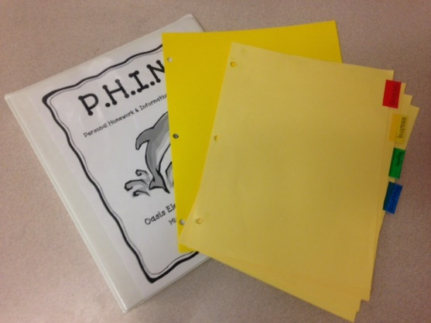 You will need:

A 1-inch white binder with clear front pocket

4-tab dividers with pockets

1 pencil pouch

1 PLASTIC pocket folder with 3-hole punches, no prongs

A permanent marker to label

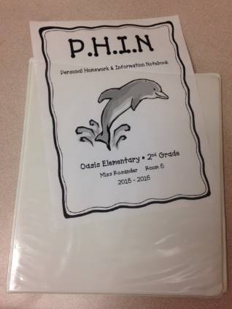

Your binder will need to

have a clear pocket on

the front. Your teacher

will supply the cover page.

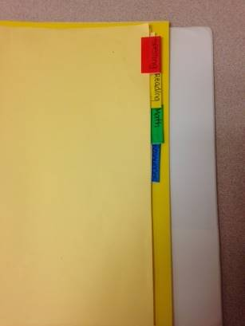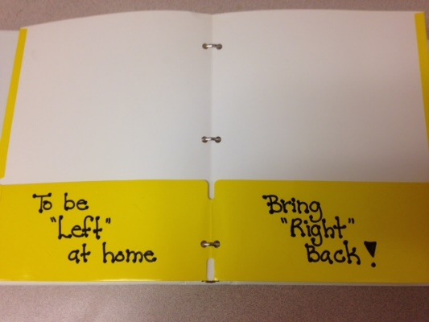Step 1: Step 2:

Label the tabs with **Homework, Place the plastic folder in the binder**

**Spelling/Fundations, ELA, and after the tabs. Label the left pocket and MATH** in that order and place with - **To Be “LEFT”** at home, label them in the binder. Place the the right pocket- **Bring “RIGHT” back**

pencil pouch in front of tabs.